Types of Tests in Java Spring Boot:   
Guide & Best Practices

Modern backend development demands robust, multilayered testing. This document defines each major test type, highlights their differences with small Java/Spring Boot examples, and summarizes how each supports reliability throughout the development and maintenance lifecycle.

**At the end, best-practice testing enhancements ensure long-term software resilience and code quality.**

1. Unit Tests

**Purpose:**Test individual methods or classes in isolation, focusing on one logical unit i.e. single unit of logic.

**Example:**

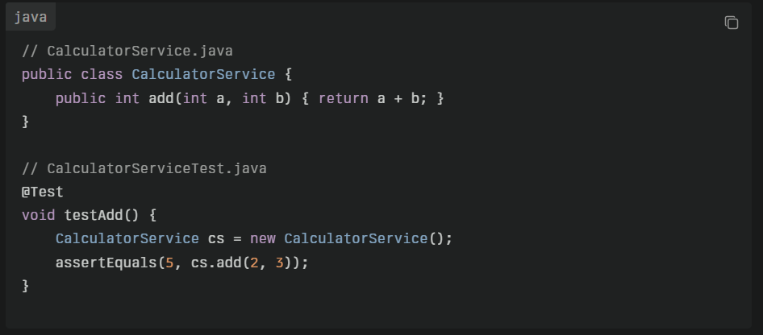

**When to Implement:**

* Early in development, as soon as new business logic or methods are added.
* **Step:** After project setup, before integration/API tests.

2. Integration Tests

**Purpose:**  
Validate interactions between multiple units/components (e.g., service with repository, DB connectivity) to ensure that units work together as expected.

**Example:**

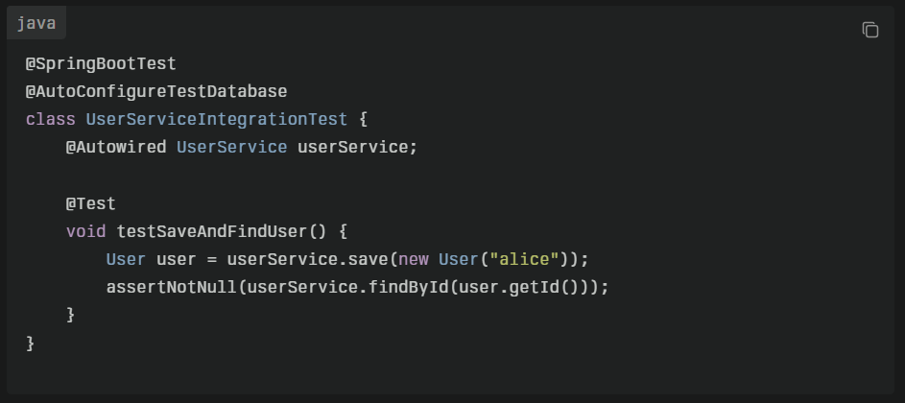

**When to Implement:**

* After basic units are tested, when system modules are connected.
* **Before major releases, after significant wiring or integration changes.**
* **Step**: Following unit test coverage, before or parallel to API tests.

3. API (End-to-End) Tests

**Purpose:**  
Test REST controllers and HTTP endpoints covering request/response validation, authentication, serialization, security and overall contract.

**Example:**

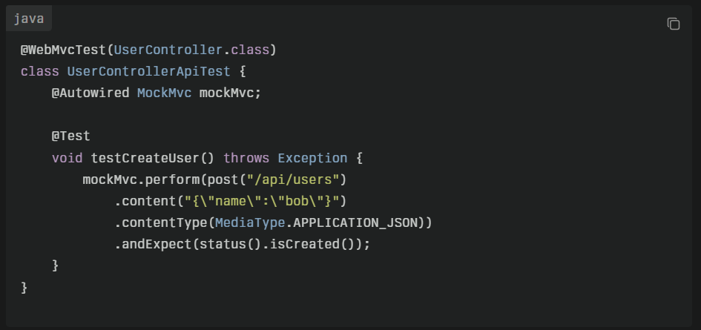

**When to Implement:**

* **After API endpoints are developed** i.e. logic is implemented and internal integrations are stable
* For contract validation and before exposing new endpoints.
* **Step**: After integration tests or when validating API contract

4. Regression Tests

**Purpose:**  
Prevent previously fixed bugs or important features from breaking during new changes. Usually consists of a suite of key unit, integration, and API tests that cover past failure points or critical flows.

**Example:**

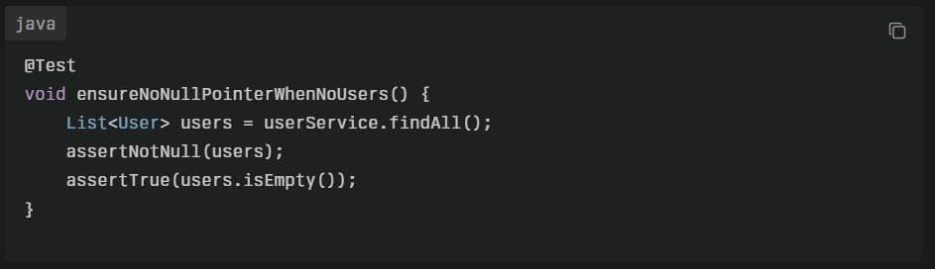

**When to Implement:**

* Whenever a bug is fixed or a core workflow is updated.
* **Regularly updated with each bug fix or change.**
* **Step:** Throughout the lifecycle; regression suite grows as new issues are discovered and fixed.

5. Test Enhancements and Best Practices

To maximize coverage, future-proofing, and risk reduction, supplement the above with these enhancements

1. **Negative & Edge Case Testing**

* **Description**: Proactively covers invalid inputs, boundary conditions, and error paths.
* **Benefit**: Makes unit and API tests more robust, ensuring code behaves correctly in less common/exceptional scenarios.
* **When**: For every logical condition, whenever error, empty, or boundary cases are possible.   
  Always add at each level (unit, integration, API) whenever business logic or API contracts make assumptions.

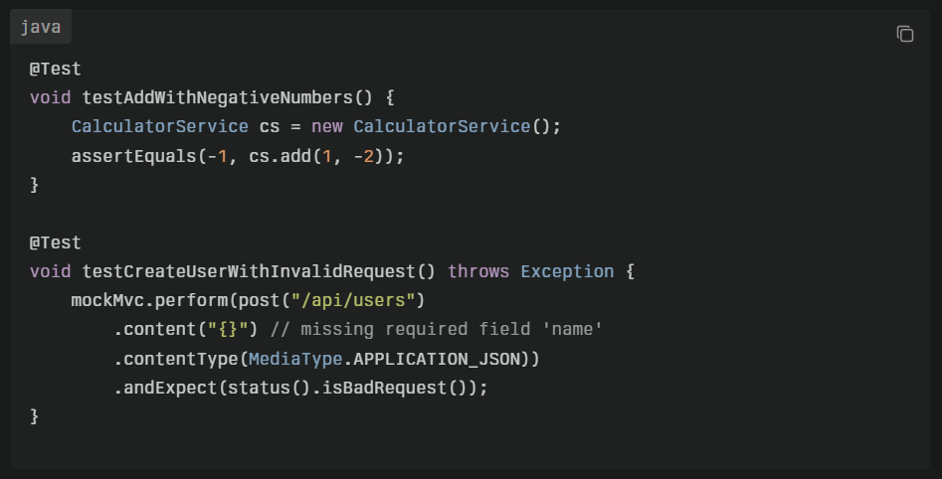

1. **Parameterized & Data-Driven Testing**

* **Description**: Runs the same test with multiple sets of data inputs.
* **Benefit**: Improves coverage, simplifies test code, and reveals unexpected issues across input spaces.
* **When**: Where functions must handle a variety of inputs or edge cases.   
  For logic with variable parameters, business rules, or input validation.
* **JUnit Example**: Use @ParameterizedTest and @ValueSource.

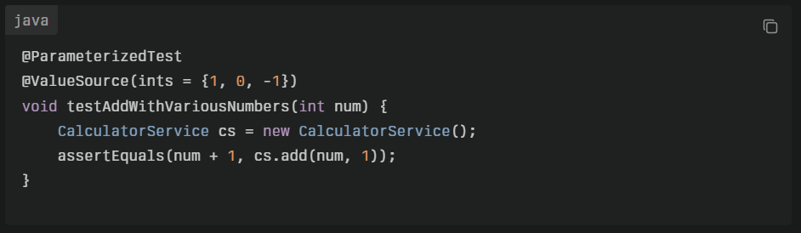

1. **Mocking and Stubbing**

* **Description**: Isolates units by replacing dependencies with controlled mock objects (using Mockito, etc.).
* **Benefit**: Enables focused unit tests without real database/external dependencies.
* **When**: In unit testing, whenever you need true isolation i.e. wherever external calls would make tests slow or nondeterministic.

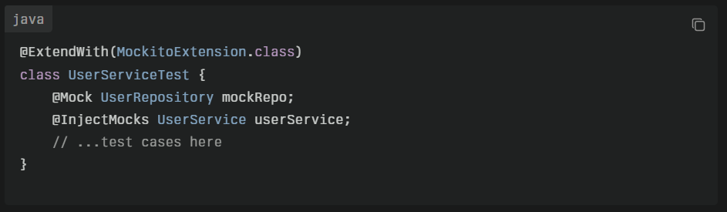

1. **Security & Authorization Testing**

* **Description**: Ensures endpoints are protected, check roles/permissions at API level.
* **Benefit**: Prevents unauthorized access; critical for production readiness.
* **When:** With API and integration tests, especially for security-critical endpoints.   
  For all endpoints or actions requiring authentication/authorization.

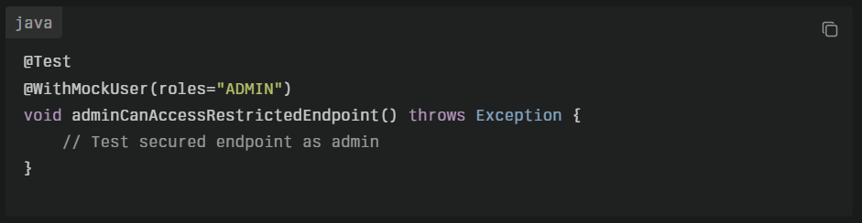

1. **Performance (Smoke/Sanity) and Health Check Tests**

* **Description**: Lightweight tests for critical-path code or “canary” checks after deployment.
* **Benefit**: Early detection of issues (slowness, resource leaks, health endpoint failures).
* **When**: As needed, e.g., simple ping or response time checks for health endpoints.  
  For critical deployments and quick system health validation after release.

1. **Test Coverage Analysis**

* **Description**: Use tools (like JaCoCo) to track which code is tested.
* **Benefit**: Identifies gaps, prioritizes future test efforts.
* **When**: After initial test suite setup and with every subsequent PR/change.  
  Routinely, especially before releases or refactoring.

1. **Test Naming and Structure Conventions**

* **Description:** Standardize test naming and folder organization.
* **Benefit:** Increases maintainability and discoverability for all future contributors.

Why Rigorous, Updated Testing Matters

* **Early Bug Detection:** Well-structured and updated tests detect issues before code reaches production.
* **Safe Refactoring:** Developers can make changes with confidence, relying on tests to prevent introducing regressions protected by automated checks.
* **Faster Releases:** Reduce manual testing effort, speed up delivery, increases consistency and deployment speed.
* **Living Documentation:** Tests act as living documentation for how code should work.
* **Lower Support Costs:** Avoids regressions and escalations.

**Risks of Neglecting Test Maintenance:**

* **Rising technical debt**: Obsolete, broken, or missing tests make code risky to change making it more fragile.
* **Increased production incidents**: Undetected defects can slip through without comprehensive, updated tests causing recurring bugs
* **Slower release cycles**: Without automated safety nets, teams rely more on manual verification.
* **Loss of knowledge**: When teams change, tests document expected behaviors—outdated tests soon become misleading.
* **Slower onboarding** for new engineers

**Best Practice:**

* **Update tests with every code change:** Always adjust, add, or remove tests alongside application changes and bug fixes.
* **Review tests during code reviews:** Ensure new logic is covered, and regression cases are present.
* **Automate runs:** Include all test types in your CI/CD pipeline for early feedback and consistent quality.

When to Implement

|  |  |  |
| --- | --- | --- |
| Step | Type of Test | Example Reference |
| After setup | Unit | CalculatorServiceTest |
| After basic units ready | Integration | UserServiceIntegrationTest |
| After endpoints built | API | UserControllerAPITest |
| After bugfixes or releases | Regression | ensureNoNullPointerWhenNoUsers |

**Summary Table**

|  |  |  |  |
| --- | --- | --- | --- |
| Test Type | Purpose | Example/Note | When |
| Unit | Isolate method/class logic | CalculatorServiceTest | First, for every core logic class |
| Integration | System of components/services | UserServiceIntegrationTest | After units are ready |
| API | Real HTTP endpoints and business flows | UserControllerApiTest | As endpoints are created |
| Regression | Protect against recurring issues | ensureNoNullPointerWhenNoUsers | After bugfixes and release cycles |
| Negative/Edge, Parms | Robustify for errors/boundaries/variety | assertThrows, ParamTest | Alongside all tests |
| Mocking | Isolate real dependencies | @Mock, @InjectMocks usage | Inside unit tests |
| Security | Validate auth, roles | @WithMockUser | All secured endpoints |
| Health/Smoke | Quick check, post-deploy | GET /health | After deploy, CI runs |
| Coverage Analysis | Ensure no logic is left untested | JaCoCo, IDE metrics | CI, pre-release, after large changes |